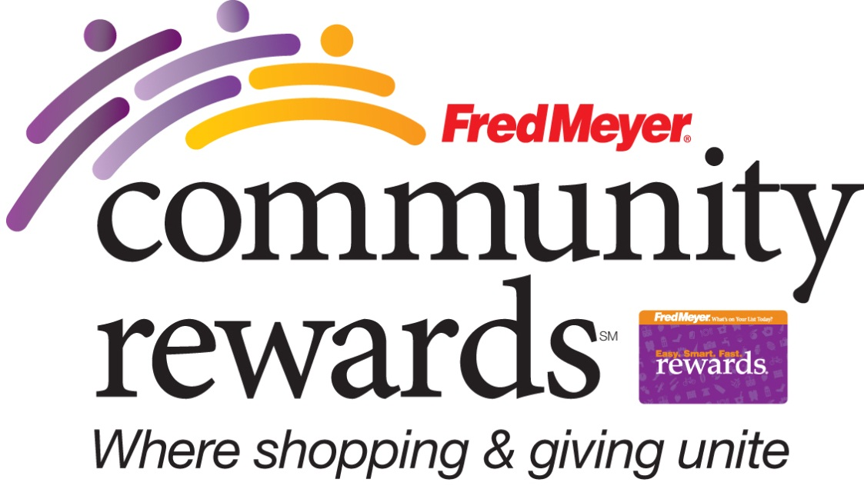

YOU CAN HELP (NON-PROFIT) EARN DONATIONS
JUST BY SHOPPING WITH YOUR FRED MEYER
REWARDS CARD!
Fred Meyer is donating $2.5 million per year to non-profits in Alaska, Idaho, Oregon and Washington, based on where their customers tell them to give. Here’s how the program works:
- Sign up for the Community Rewards program by linking your Fred Meyer Rewards Card to (non-profit) at www.fredmeyer.com/communityrewards. You can search for us by our name or by our non-profit number (89550).
- Then, every time you shop and use your Rewards Card, you are helping (non- profit) earn a donation!
- You still earn your Rewards Points, Fuel Points, and Rebates, just as you do today.
- If you do not have a Rewards Card, they are available at the Customer Service desk of any Fred Meyer store.
- For more information, please visit www.fredmeyer.com/communityrewards.

